**TABLE OF CONTENTS**

1. **Login by admin**…………………………………………………………………………1
   1. Admin dashboard……………………………………………………………………………...2
   2. Adding a doctor………………………………………………………………………………...3
   3. Viewing doctor…………………………………………………………………………………4
   4. Logging out……………………………………………………………………………5
2. **Patient** …………………………………………………6

2.1 register…………………………………………………………………..7

* 1. login……………………………………………………………………8

2.3 Make an appointment………………………………………………………………………….9

2.4view progress………………………………………………………….10

2.5chat with my doc……………………………………………………..11

2.6logging out………………………………………………………………………12

**3.Dctor login…………………………………………………………………………**13

3.1 doctor dashboard …………………………………………………………….14

3.2 view appointments………………………………………………………15

3.3 update appointment……………………………………………………………………16

* 1. Login page: As an administrator

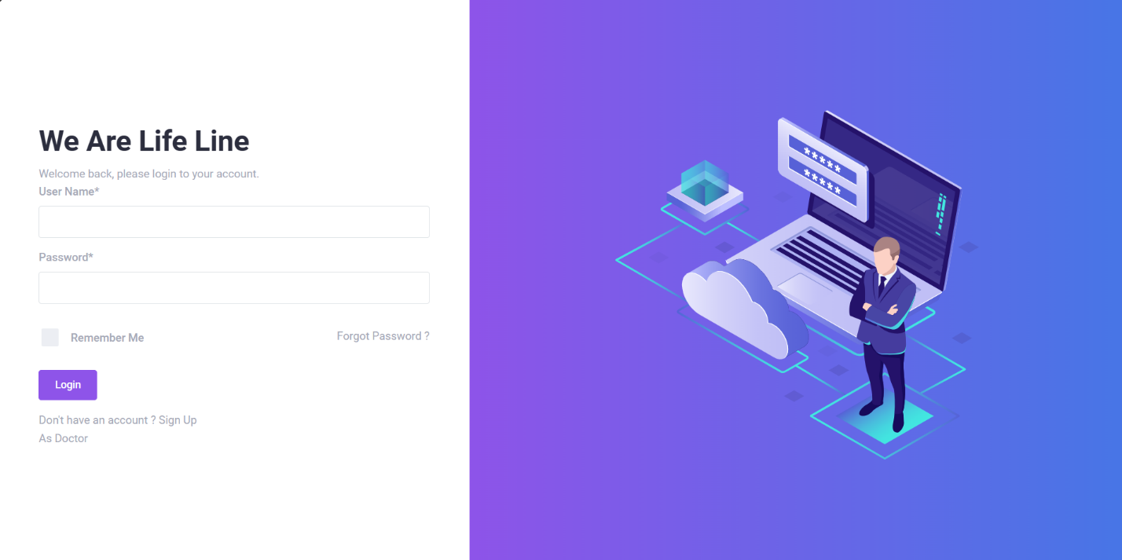

This is the landing login page which the administrator, doctor and patient uses. And to login as an administrator, we had already defined username and password as

Username: Tony

Password: admin

After a successful login you should be able to see the following screen

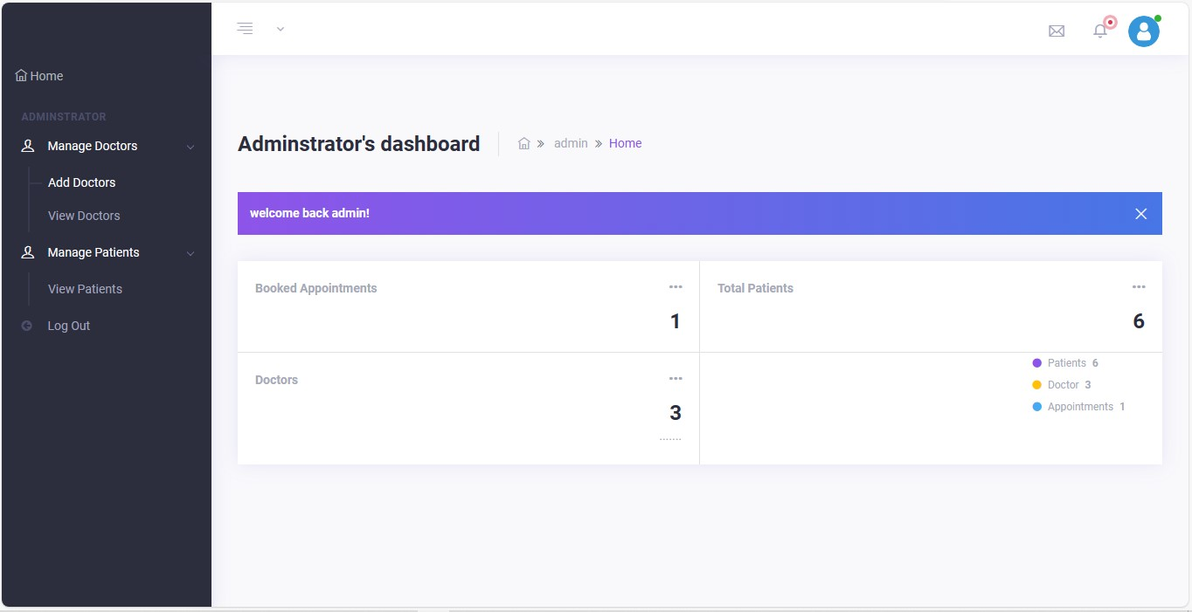

On the left there’s actions the administrator is performing i.e., on managing doctor’s the admin is adding and viewing doctors in the system. So, you should be able to see the following screen when managing doctors and the action is adding a doctor

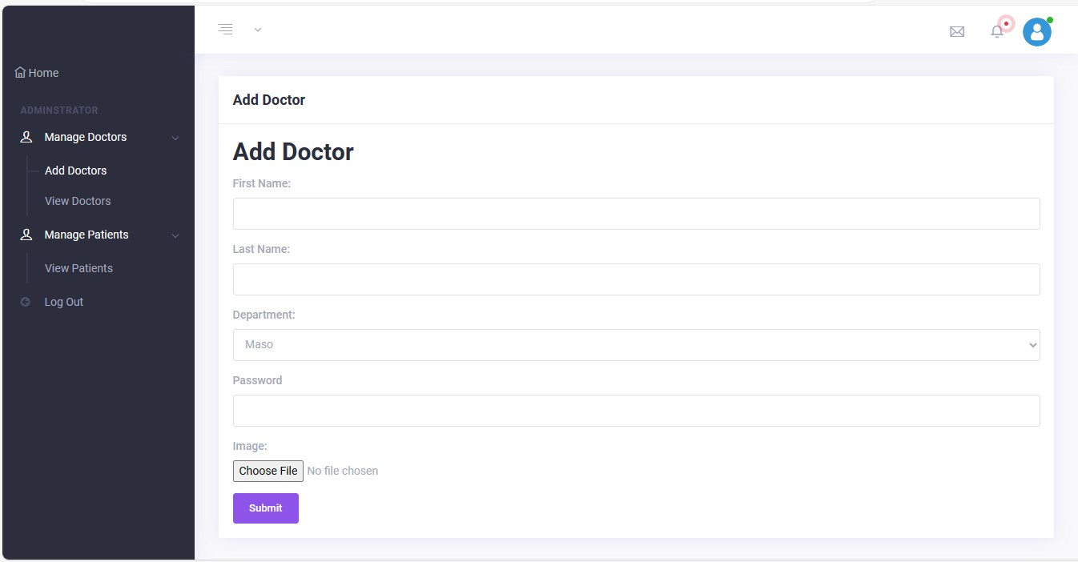

Note: doctors accounts are created by the administrator so the details that are input here are used by doctors when logging in and the system takes the first name as the username.

After successfully adding a doctor, the admin should be able to view them as the following screen shows.

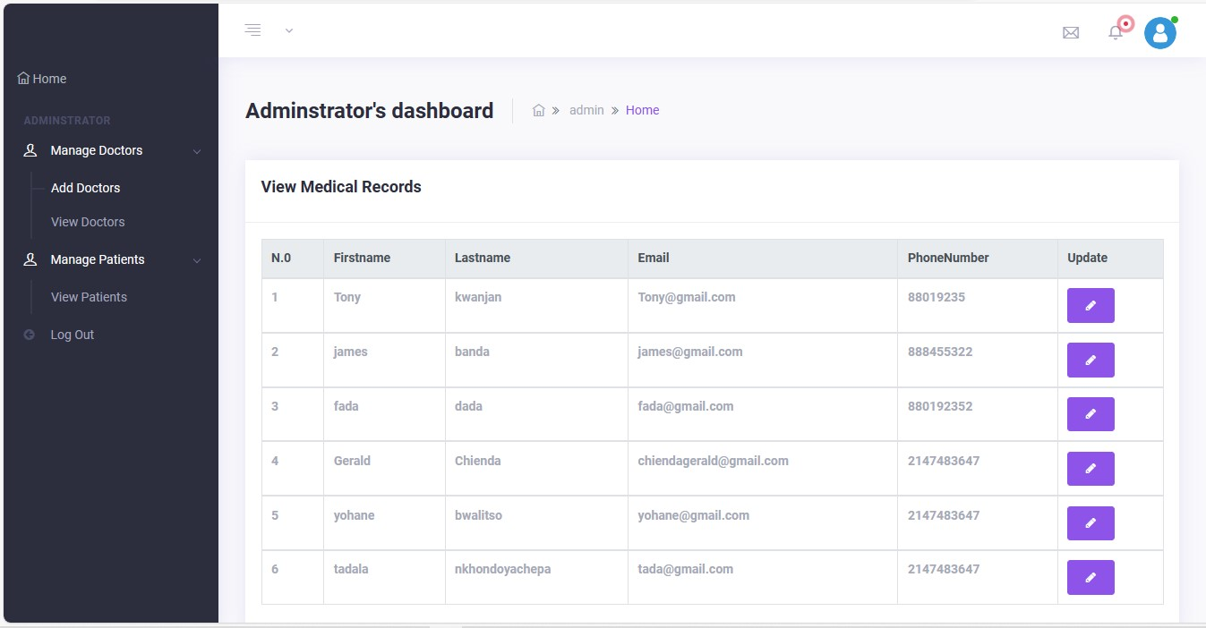

Note: patients accounts are created by the patients themselves.

Adding a department

The administrator clicks department to add or view a department, in the case of adding a department the screen shows as follows:

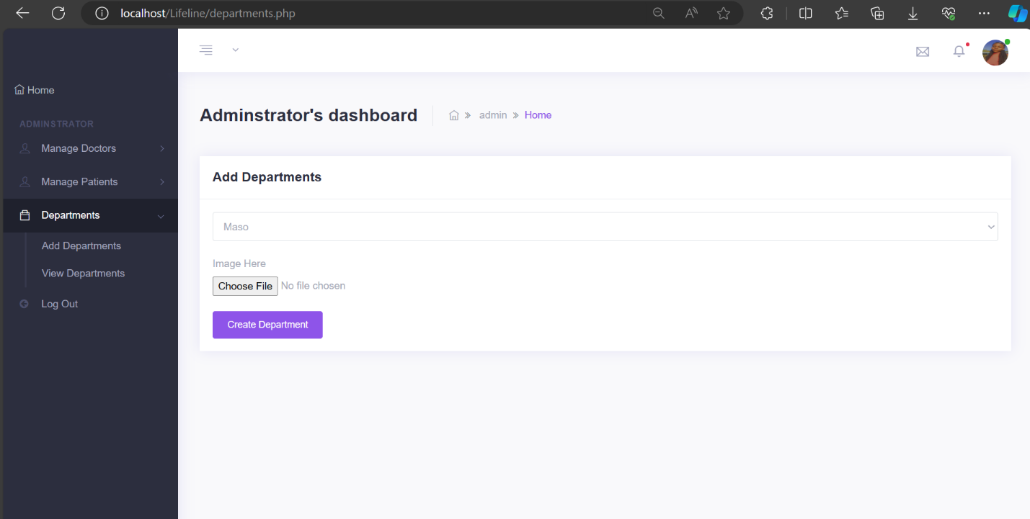

Finally, the admin can log out by clicking log out at the bottom on the left and it shall ask him/her if is sure to log out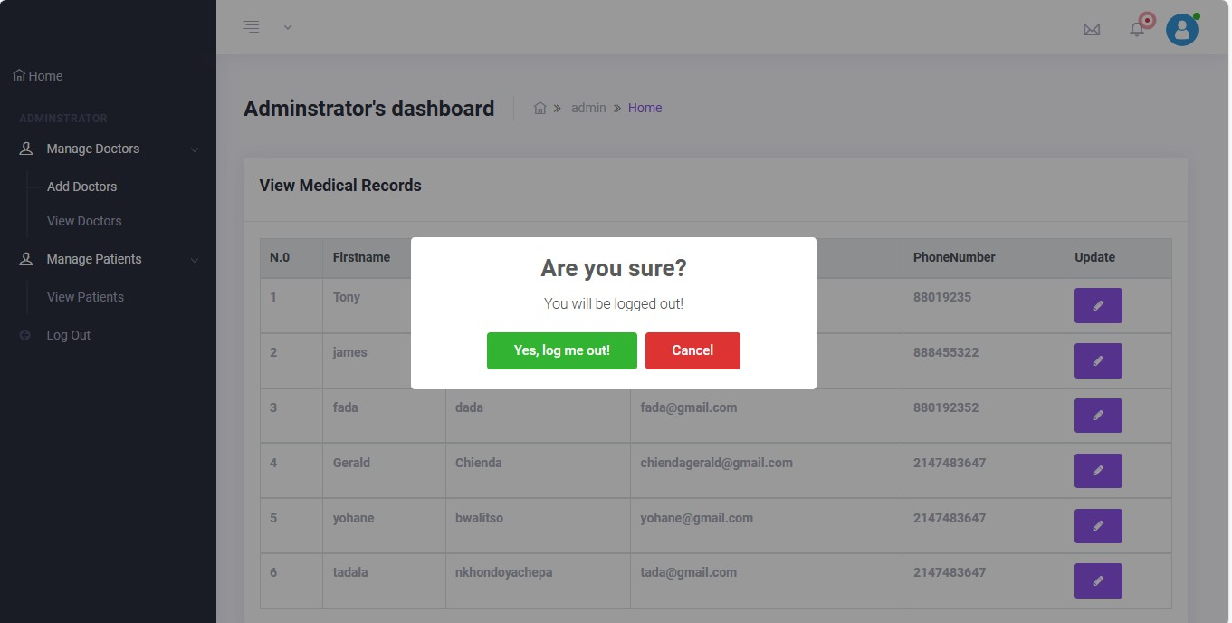

when accepts it takes back to the landing page ,the following is the home page or landing page:



* 1. Creating an account as a patient and Loggin in

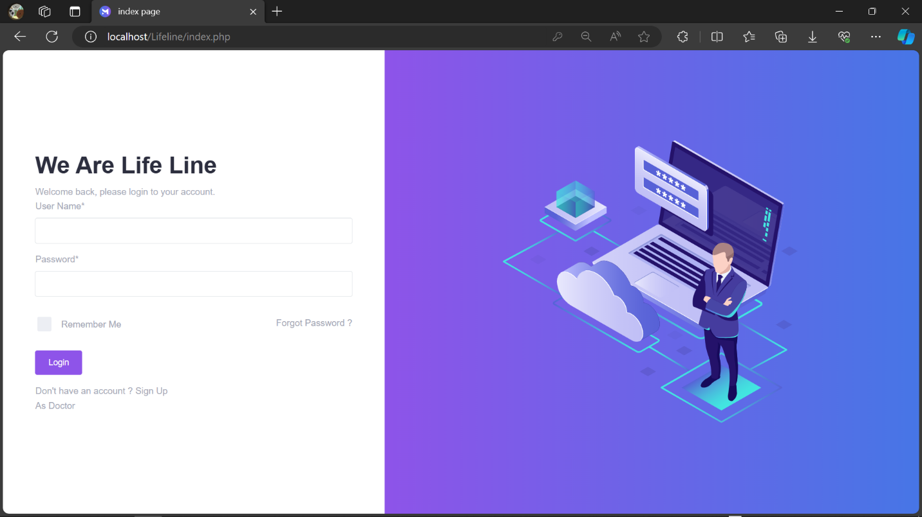

The patient has to click sign up in order to create an account and once that is done, the following page displays.

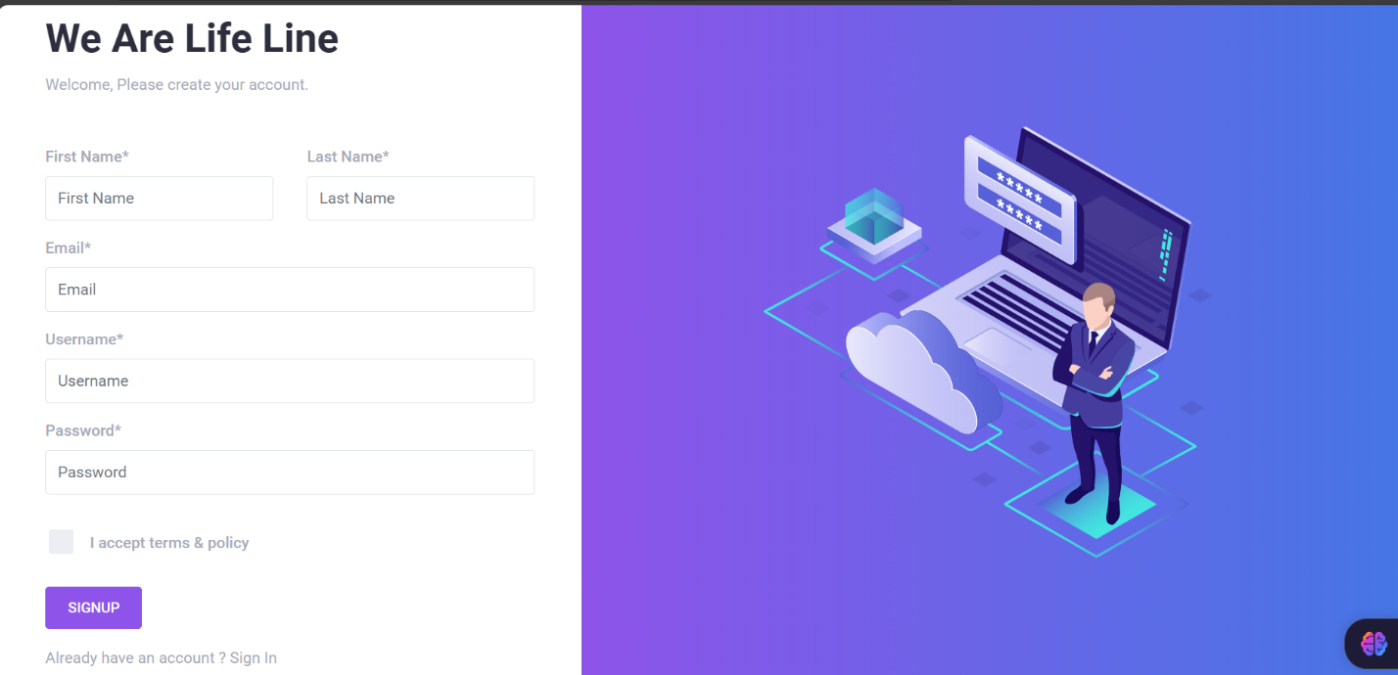

Having completed the details, you may go back to sign in

Note: the system takes the first name as the username so remember to use the first name as username when logging in. after a successful login you should be able to see the following screen.

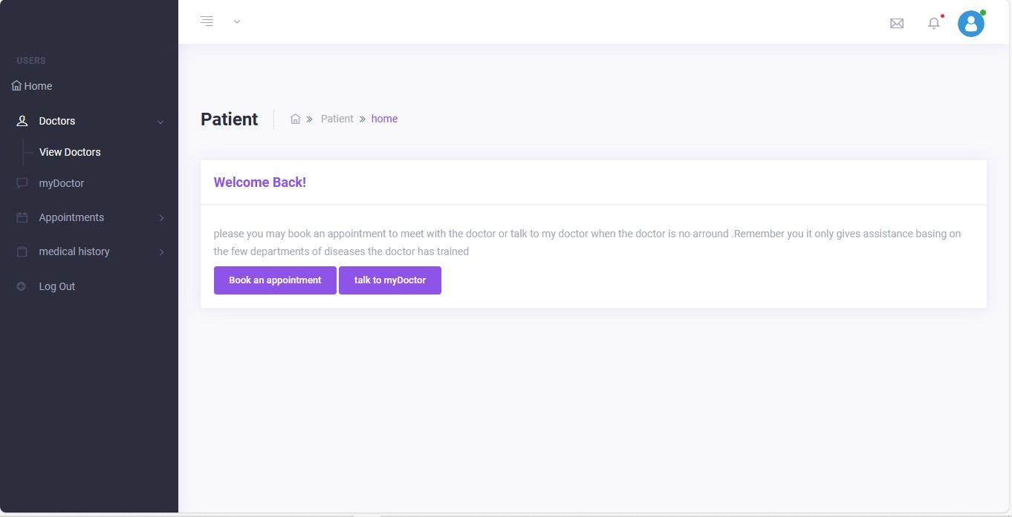

On the right it’s a panel that shows what the patient is doing in the system, the patient is able to view the doctors, book appointment, see the medical history, view the departments and talk to the chatbot that responds to the questions the patient is prompting it.

1. Viewing doctors: the following screen appears showing the doctors image, and the department the doctor works.

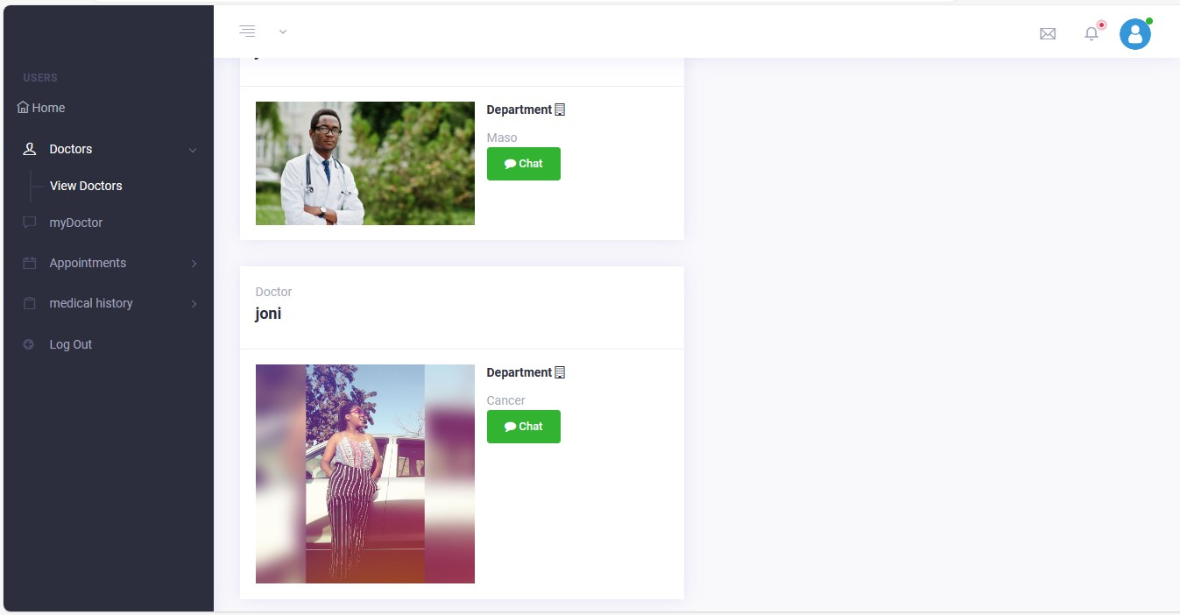

1. Viewing progress of appointment:

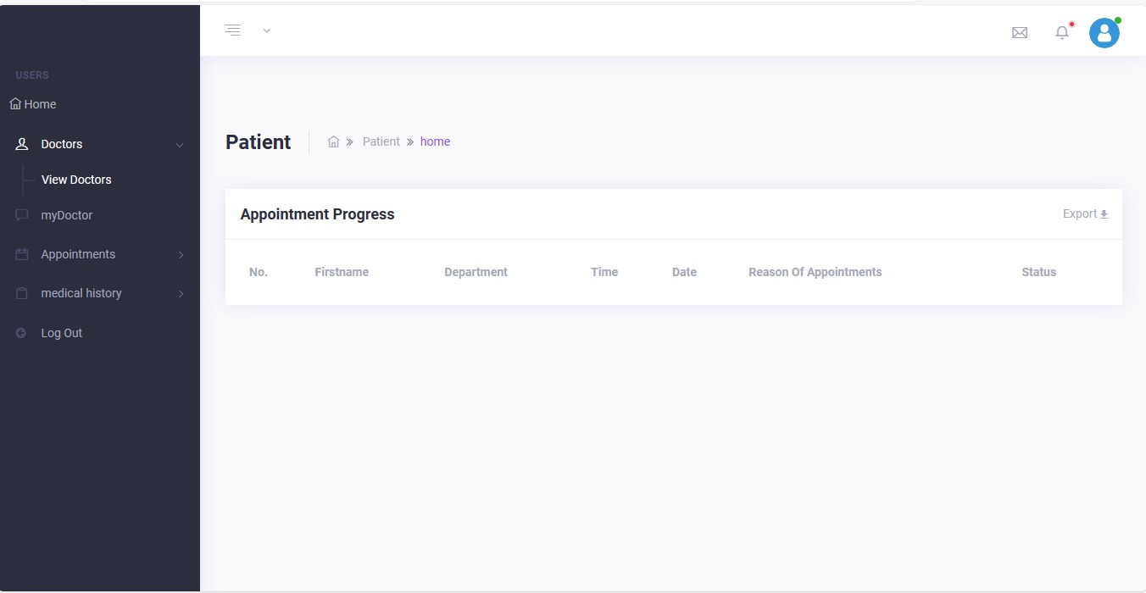

1. Interacting with the chatbot

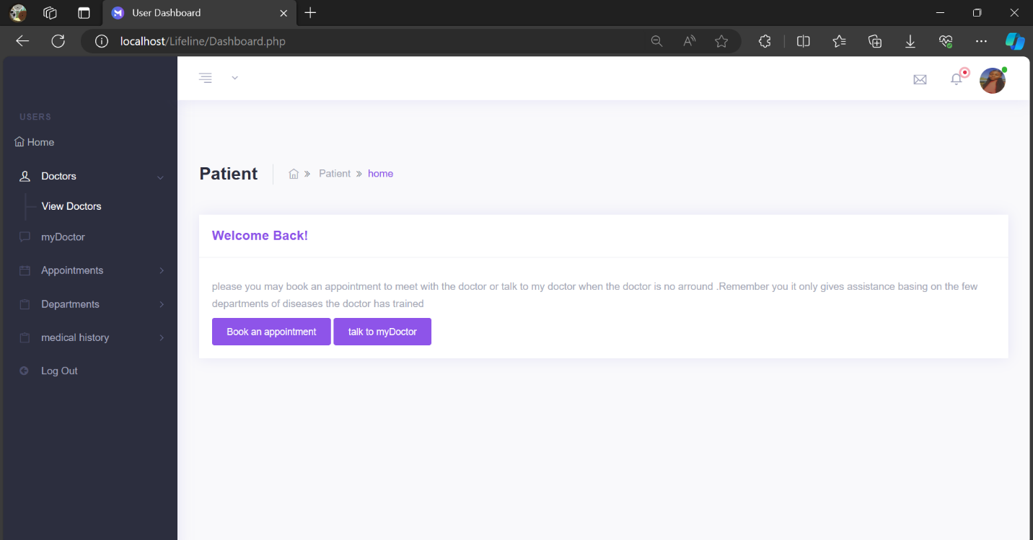

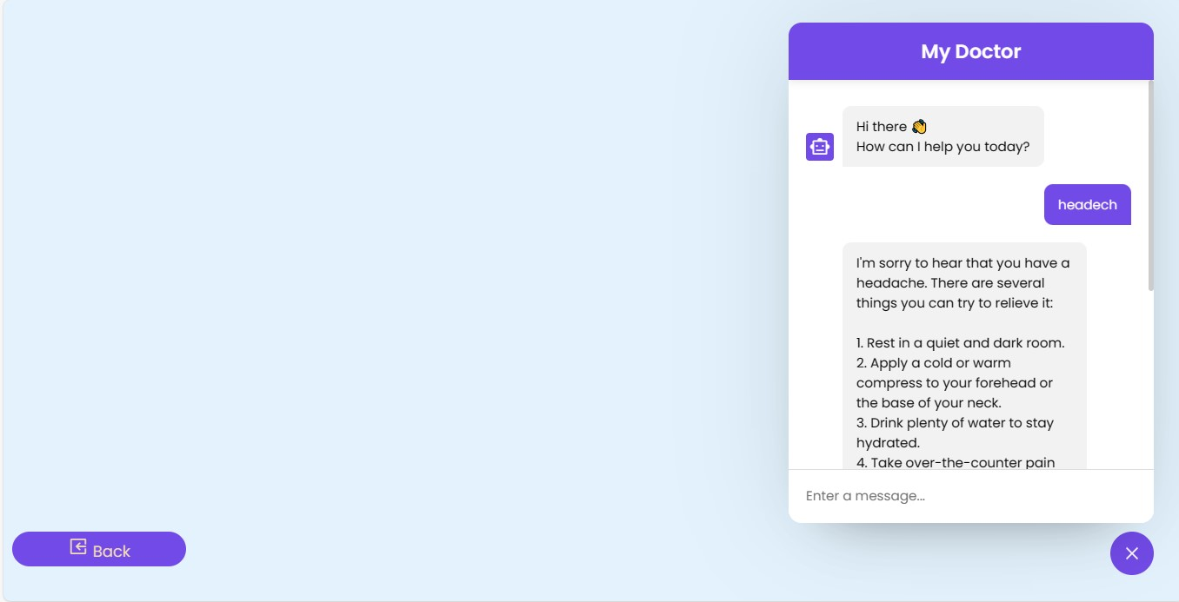

A patient clicks on talktomydoctor to interact with the chat bot.

1. Appointments :

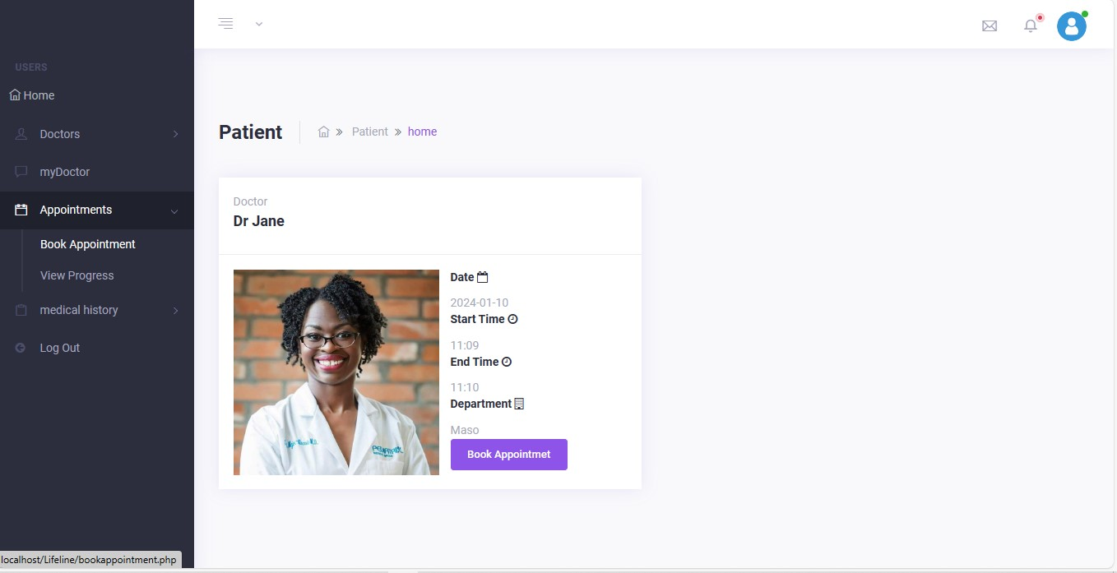

1. View Medical history :

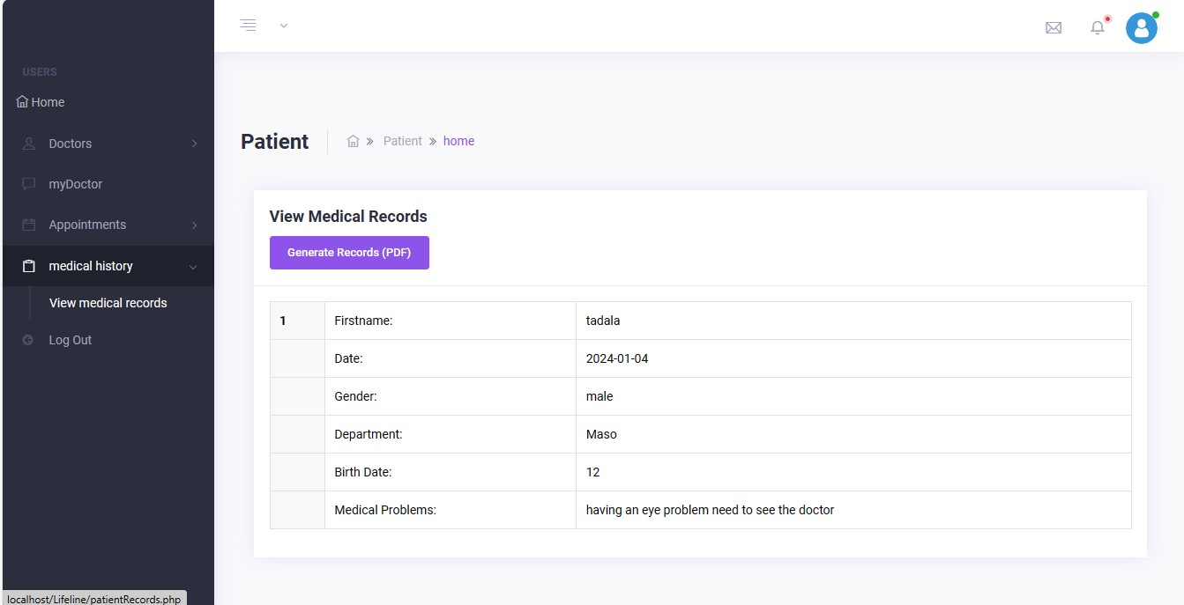

Logging out

Once the patient is done, at the bottom left he / she clicks to log out of the system and once accept the action it will take the user back to the first page. Everything is shown with the screens as follows

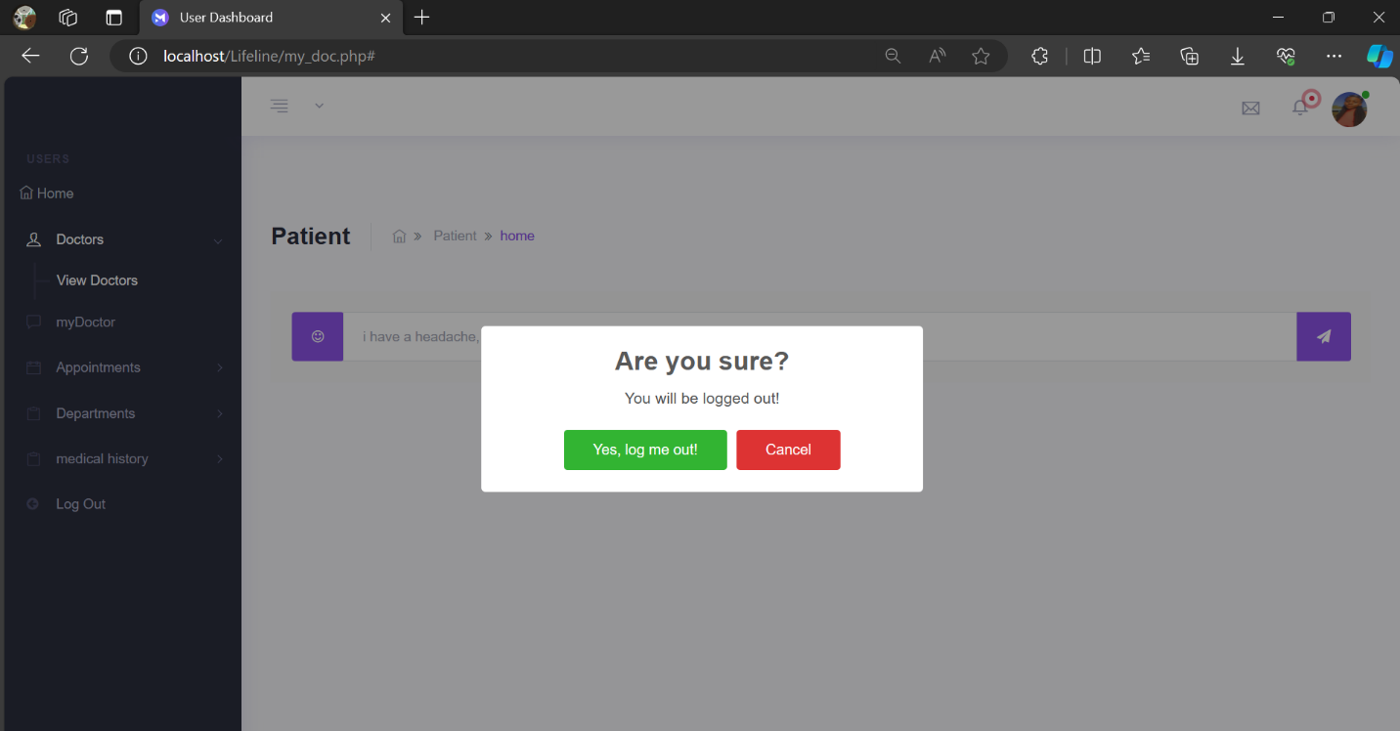

Homepage/ landing page:



* 1. Logging in as a doctor



Click as a doctor on the home page to login as a doctor and it should take you to the following page

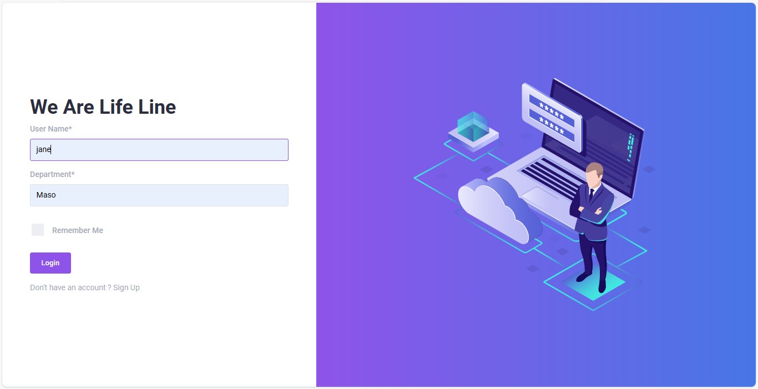

After a successful login you should be able to see the following screen

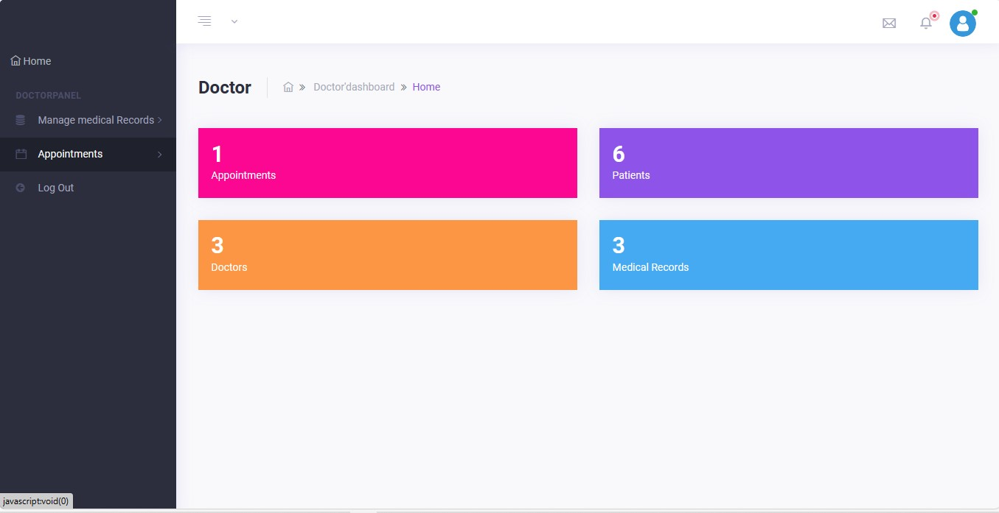

1. Doctor can view appointments according his/her department:

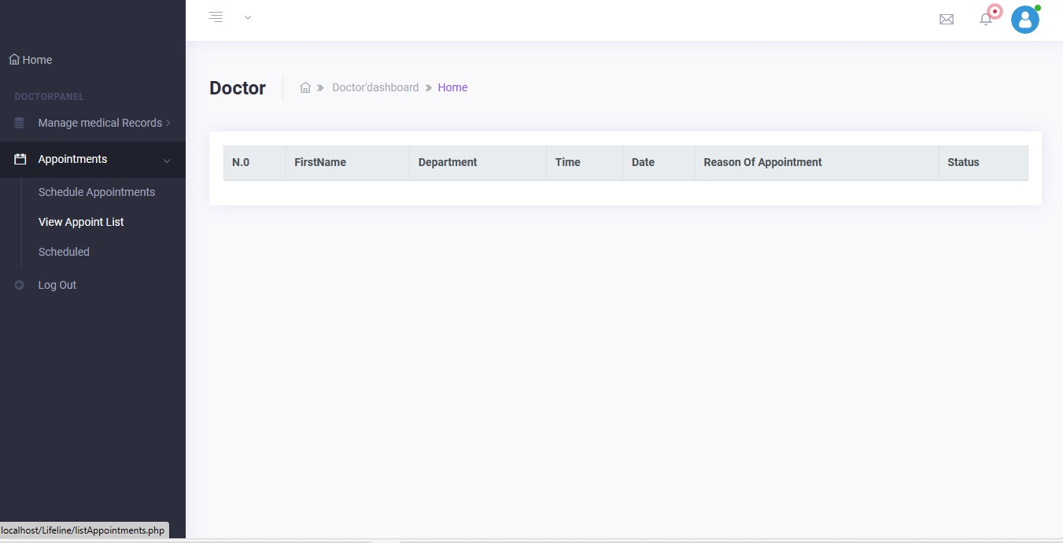

1. Appointments :

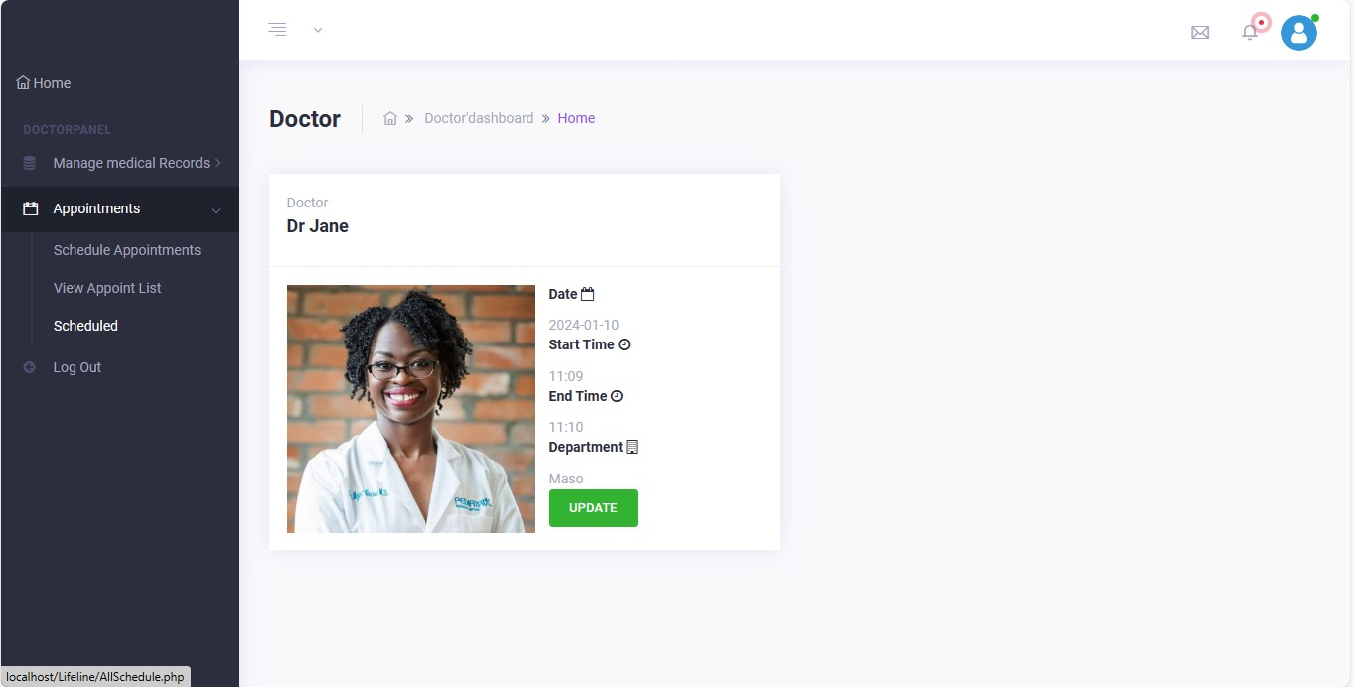

1. Logging out:



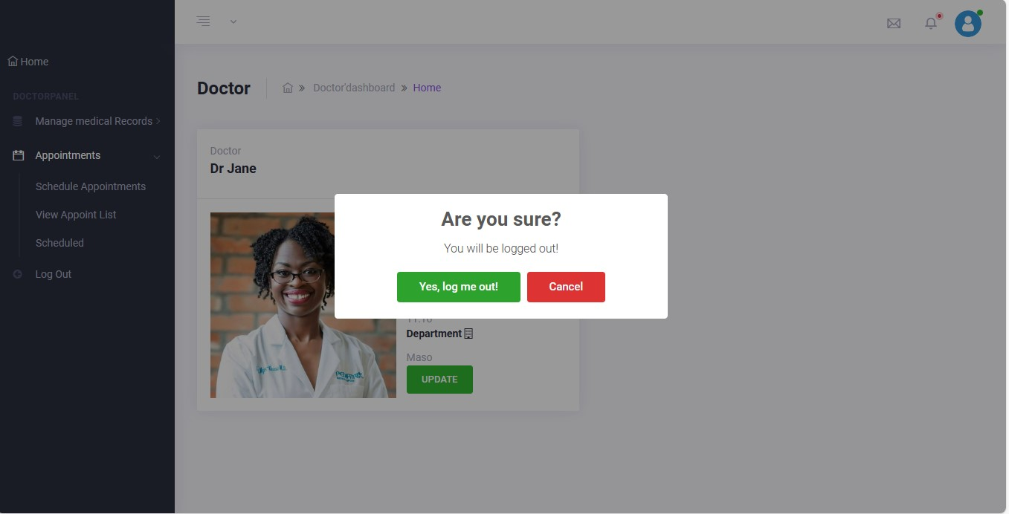

If yes it takes you back to the home page.